1/7/2023

bilal mazhar

DevOps - University

**Tools Installation**

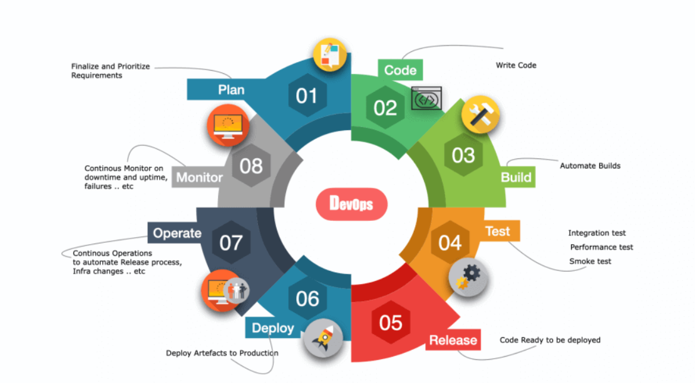

1. **Executive Summary:**

DevOps is a cultural and technical movement that aims to improve the collaboration and communication between development and operations teams, and to automate as much of the software delivery process as possible. The goal of DevOps is to enable organizations to deliver software faster and more reliably, and to respond more quickly to changing business needs.

One of the key principles of DevOps is the use of automation. Automation helps teams reduce the time and effort required to build, test, and release software, and can help eliminate errors and improve the quality of the software. Automation also helps teams deploy code changes more frequently and with less risk, which can enable organizations to respond more quickly to changing business needs.

To automate the software delivery process, teams often use a variety of tools. Some examples of common DevOps tools include:

* **Continuous integration (CI) and continuous delivery (CD**) tools such as Jenkins and CircleCI, which help teams build and test code automatically whenever changes are made to the codebase.
* **Configuration management** tools such as Ansible, Puppet, and Chef, which help teams automate the process of configuring and managing servers and infrastructure.
* **Containerization tools** such as Docker and Kubernetes, which help teams package and deploy applications in a consistent and portable way.
* **Monitoring tools** such as Prometheus and New Relic, which help teams track the performance and availability of their applications and infrastructure.

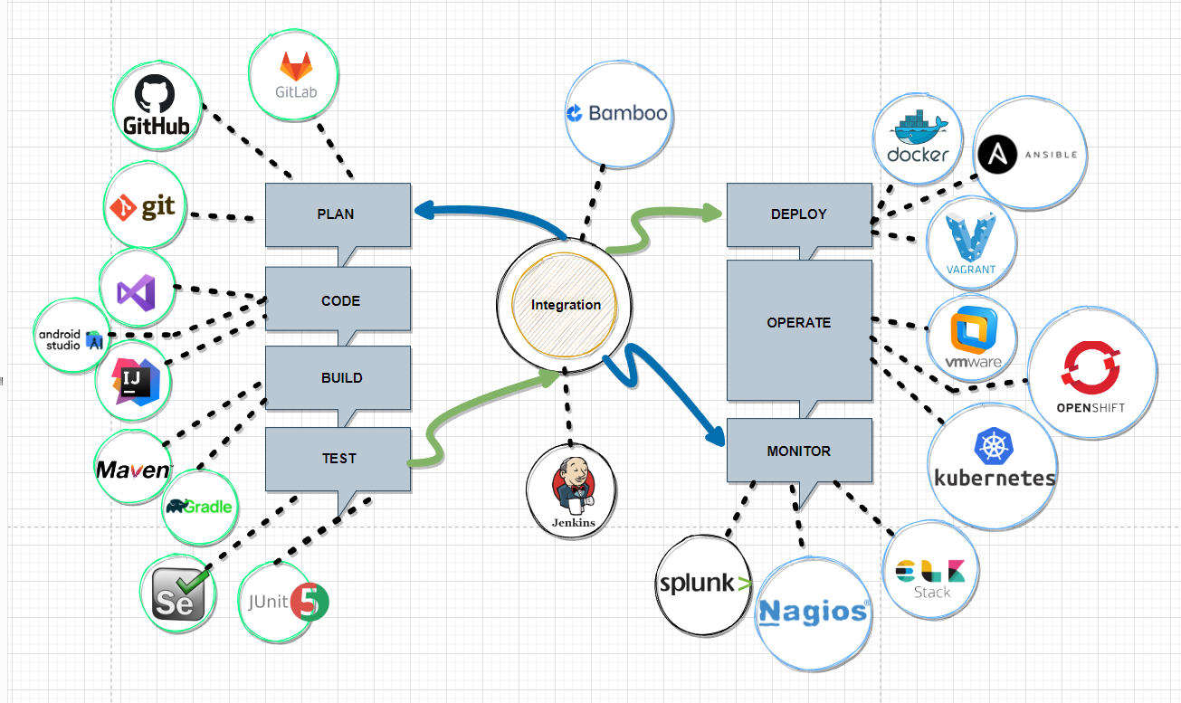

In addition to automation, DevOps also emphasizes the importance of collaboration and communication between development and operations teams. Traditionally, these teams have often operated in silos, with development focused on writing code and operations focused on deploying and managing the infrastructure. DevOps aims to break down these silos and encourage teams to work together more closely, with the goal of improving the overall efficiency and effectiveness of the software delivery process.

One way that DevOps promotes collaboration is through the use of agile methodologies, which focus on iterative and incremental development. Agile practices such as Scrum and Kanban help teams prioritize and deliver value in small increments and encourage collaboration and communication between team members.

Learning DevOps can be a valuable skill for professionals working in software development and operations roles. It can help individuals understand how to build and release software more efficiently and effectively and can help organizations deliver better software faster. To learn DevOps, individuals can take online courses, attend conferences and meetups, or join a DevOps community. Some organizations also offer in-house training programs or hire consultants to help teams adopt DevOps practices.

In conclusion, DevOps is a cultural and technical movement that aims to improve collaboration and communication between development and operations teams, and to automate as much of the software delivery process as possible. By using tools to automate tasks and adopting agile methodologies, teams can deliver software faster and more reliably, and respond more quickly to changing business needs. Learning DevOps can be a valuable skill for professionals working in software development and operations roles and can help organizations deliver better software faster.

1. **List of Tools**

|  |  |  |  |
| --- | --- | --- | --- |
| ***Sr.*** | ***Tools*** | ***Description*** | ***Download Link*** |
| 1 | Linux | Linux is a free and open-source operating system and a popular choice for servers and is also used on a wide range of devices, including smartphones, tablets, and laptops. One of the key features of Linux is its command-line interface, which allows users to interact with the operating system using commands and scripts. | <https://ubuntu.com/download/desktop> |
| 2 | Jenkins | an open-source continuous integration and delivery (CI/CD) tool that helps teams automate the build, test, and deployment of software. | <https://www.jenkins.io/download/> |
| 3 | Git / GitHub | Git is a version control system that helps teams manage and track changes to source code | <https://git-scm.com/download/win>  <https://desktop.github.com/> |
| 4 | Docker | an open-source containerization platform that helps teams’ package and deploy applications in a consistent and portable way. | <https://www.docker.com/> |
| 5 | Kubernetes | an open-source container orchestration platform that helps teams deploy and manage containerized applications at scale. | <https://microk8s.io/> |
| 6 | Splunk | Splunk is a software platform that helps organizations search, analyze, and visualize data generated by their IT systems and technology infrastructure. It is commonly used for log management, security, and compliance, and can process and analyze large volumes of data in real-time. | <https://www.splunk.com/en_us/download.html> |
| 9 | Nagios | Nagios is an open-source monitoring tool that was designed to serve the purpose of monitoring the different networking apps, their sources, and various Linux based devices. With Nagios, we can be vigilant of any critical activities and events of software malfunctions by sending automated alerts to the admins and prevent further damages | <https://www.nagios.org/> |
| 10 | Prometheus | an open-source monitoring tool that helps teams track the performance and availability of their applications and infrastructure. | <https://prometheus.io/> |
| 11 | ELK | ELK is an acronym that refers to three open-source projects: Elasticsearch, Logstash, and Kibana. These tools are commonly used together to create a centralized logging solution for IT infrastructure and applications. |  |
| 12 | Ansible | an open-source configuration management tool that helps teams automate the process of configuring and managing servers and infrastructure. |  |
| 13 | OpenStack |  | <https://microstack.run/docs/single-node> |

1. **Linux Installation**

Linux is a free and open-source operating system that was created in the early 1990s by Linus Torvalds. It is based on the Unix operating system and is used on a wide range of devices, including servers, desktops, laptops, and mobile phones.

One of the main advantages of Linux is that it is highly customizable and can be tailored to meet the specific needs of an organization or individual. It is also highly stable and secure, making it a popular choice for servers and critical infrastructure.

Linux is typically used in a command-line interface (CLI), although graphical user interfaces (GUIs) are also available. It includes a wide range of tools and utilities for tasks such as file management, text editing, and system administration.

Linux is used by a wide range of organizations, including government agencies, universities, and businesses. It is also popular among individuals who are interested in learning about operating systems and programming.

There are many different versions (also known as distributions) of Linux available. Some popular examples include:

* Ubuntu: a user-friendly distribution that is popular on desktop computers and servers.
* CentOS: a stable and secure distribution that is popular on servers and is based on the Red Hat Enterprise Linux distribution.
* Fedora: a distribution company that is sponsored by Red Hat and is focused on cutting-edge features and technologies.
* Debian: a distribution company that is known for its stability and is popular on servers and desktop computers.
* Arch Linux: a distribution that is popular among advanced users and is known for its flexibility and customizability.
* Linux Mint: a user-friendly distribution that is based on Ubuntu and is popular on desktop computers.

**These are just a few examples, and there are many other distributions available as well. The right distribution for you will depend on your specific needs and preferences.**

* Red Hat Package Manager (RPM) and Debian are two different package management systems that are used to install, update, and remove software on Linux systems. Both systems are widely used, and there are a number of differences between them.
* One key difference is the type of distribution they are used on. RPM is primarily used on Red Hat-based distributions such as CentOS, Fedora, and Red Hat Enterprise Linux, while Debian is used on distributions such as Debian, Ubuntu, and Linux Mint.
* Another difference is the format of the packages themselves. RPM uses binary packages with the .rpm file extension, while Debian uses binary packages with the .deb file extension.
* There are also some differences in the tools and commands used to manage packages. For example, the rpm command is used to manage RPM packages, while the apt command is used to manage Debian packages.

For installation we will used ubuntu and can be found: <https://ubuntu.com/download/desktop>

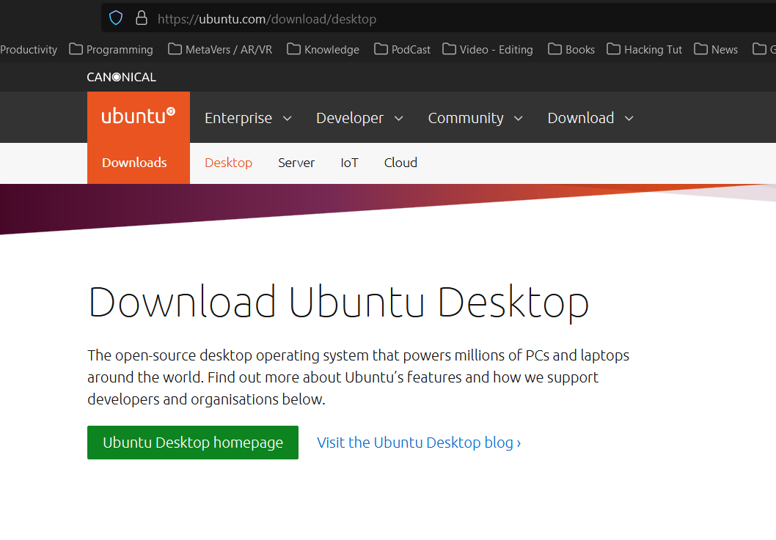

**Step: 1** Download ISO

**Step 2**: Install VMware or Virtual Box, I will use VMware

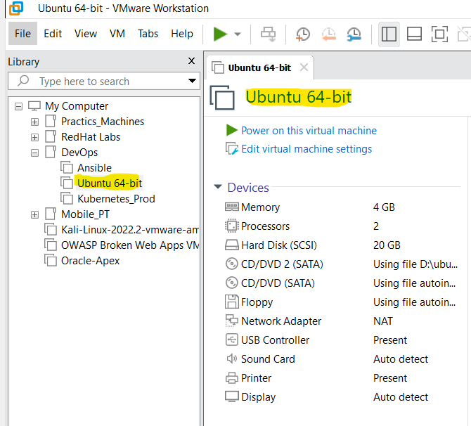

**Step 3:** Start the VM

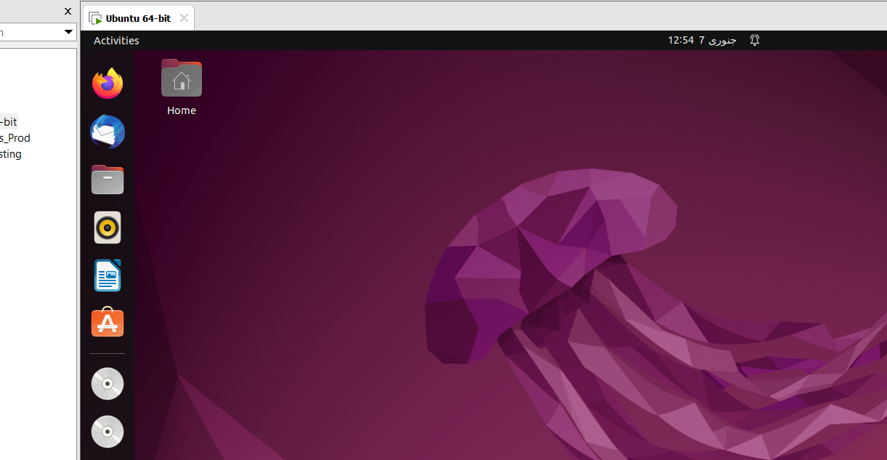

**Linux is now successfully installed!!!!!!!!!!!**

1. **Jenkins Installation**

* Jenkins is an open-source automation server that is used to automate parts of the software development process. It is written in Java and is commonly used for continuous integration and continuous delivery (CI/CD) of software applications.
* With Jenkins, developers can automate tasks such as building, testing, and deploying software. It can be used to automate a wide range of tasks, including building, testing, and deploying software applications, running tests, and deploying infrastructure.
* Jenkins is highly configurable and can be customized to meet the specific needs of an organization or project. It has a wide range of plugins available that allow it to integrate with other tools and systems, such as source code repositories, build tools, and deployment environments.
* Jenkins is used by a wide range of organizations, including small startups and large enterprises. It is a popular choice for CI/CD because it is open source, has a large community of users and developers, and is highly extensible

**Step 1:** Install Update on Ubuntu

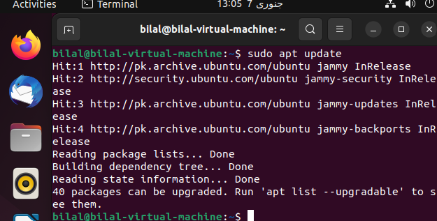

**Step 2:** Install Java on Ubuntu

**Step 3:** Download war file from the repo : <https://get.jenkins.io/war/latest/jenkins.war>

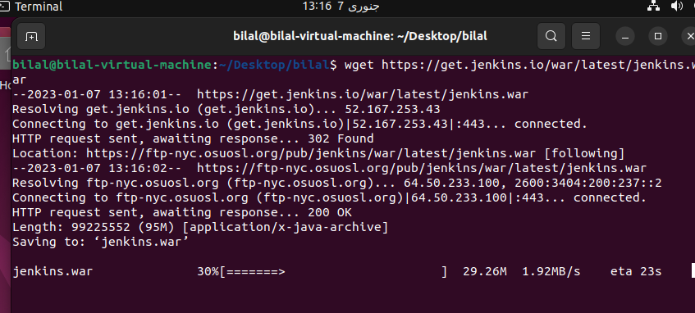

**Step 4:** Run java file

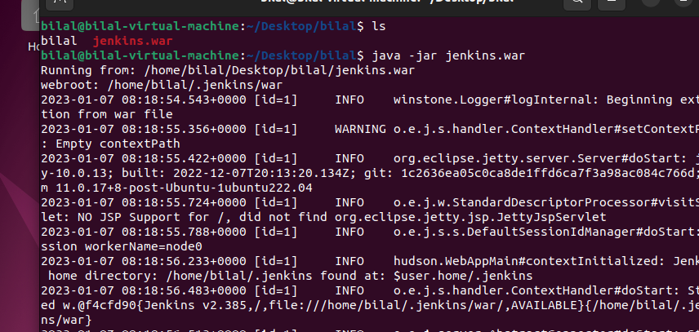

**Step 5:** Copy Password generated by Jenkin

**Step 6**: Paste the code which was copy earlier

**Step 7**: Select “**Install Suggested Plugins** “

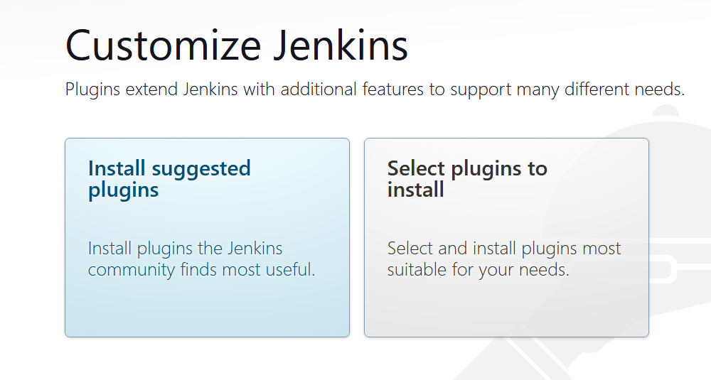

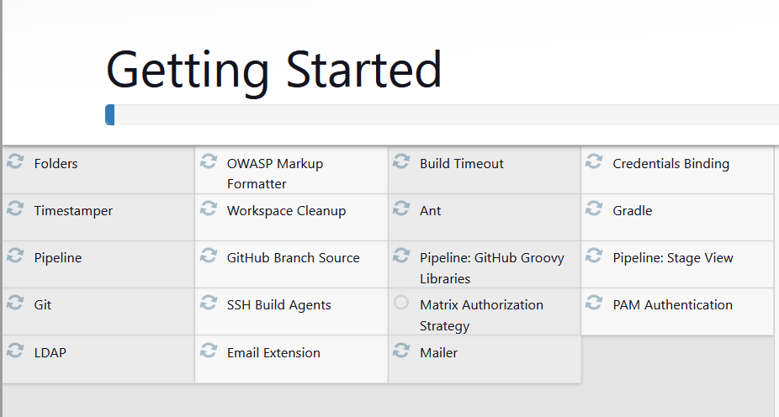

**Step 8**: Click “**Start using Jenkins** “.

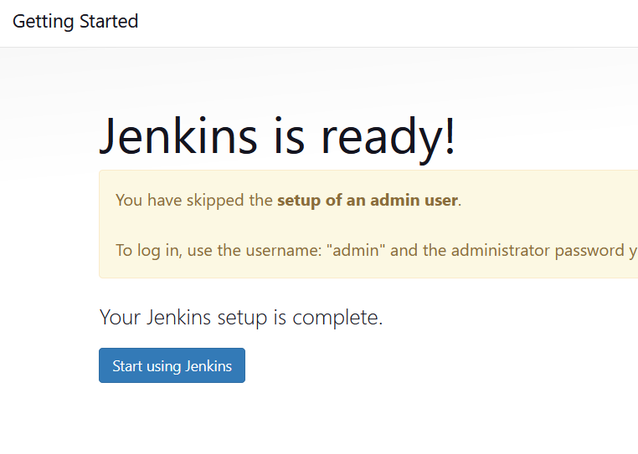

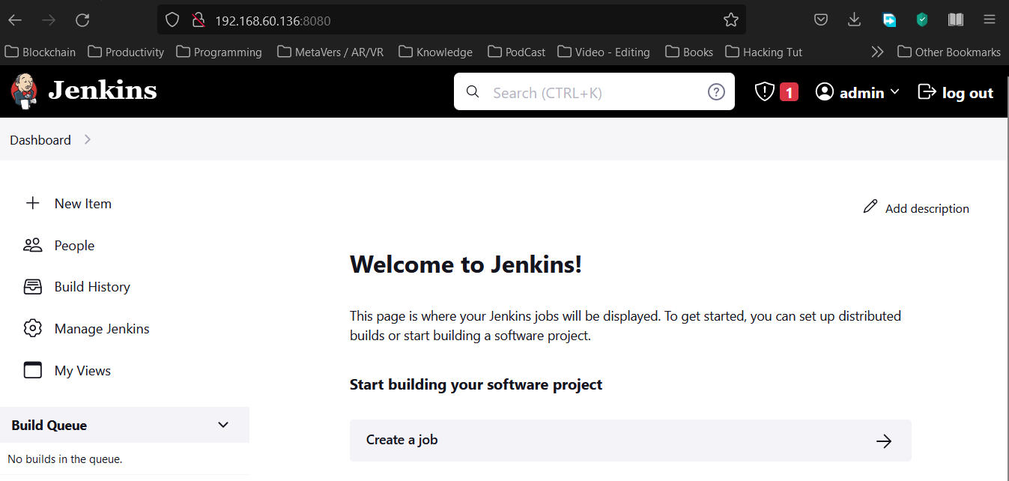

**Jenkins is now successfully installed!!!!!!!!!!!!**

1. **Git / GitHub**

* Git is a version control system that is used to track changes to files and coordinate work between multiple people. It was created by Linus Torvalds in 2005 and is widely used by developers to manage source code for software projects.
* Git is distributed, which means that each person who works on a project has a complete copy of the project's history on their local machine. This makes it easy for people to work on projects even when they are offline or disconnected from the network.
* Git is used by a wide range of organizations, including small startups and large enterprises. It is a popular choice for version control because it is open source, has a large community of users and developers, and is widely supported by a range of tools and services.

**Step 1:** Download install

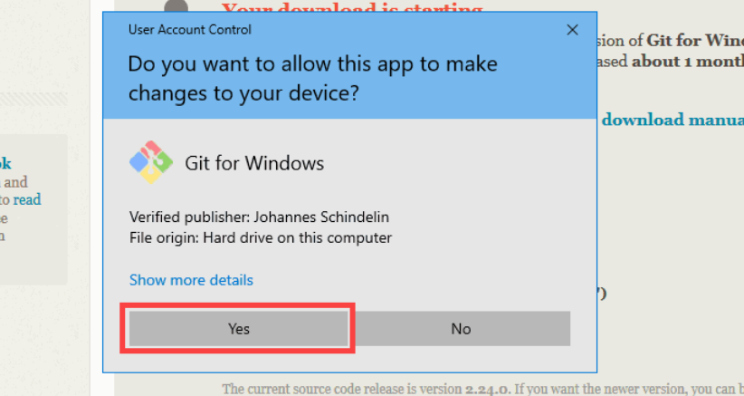

**Step 2:** Install according to the choice

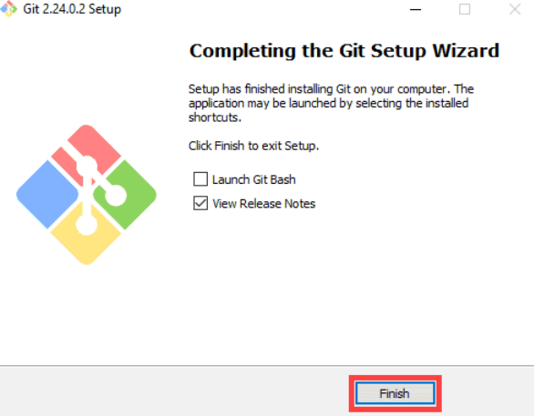

**Step 3:** To verify type git command in your terminal

**Git is now successfully installed!!!!!!!!!!!!**

1. **Docker**

* Docker is a tool designed to make it easier to create, deploy, and run applications by using containers. Containers allow a developer to package an application with all of the parts it needs, such as libraries and other dependencies, and ship it all out as one package.
* Docker allows developers to create and deploy applications in containers, which can be run on any machine that has Docker installed. This makes it easy to deploy applications consistently across environments, such as development, testing, and production.
* Docker is based on open-source technology and is available on a wide range of platforms, including Linux, Windows, and Mac. It is widely used by developers to build, test, and deploy applications, and is also used by organizations to deploy and run applications at scale.

**Step 1:** Install Docker

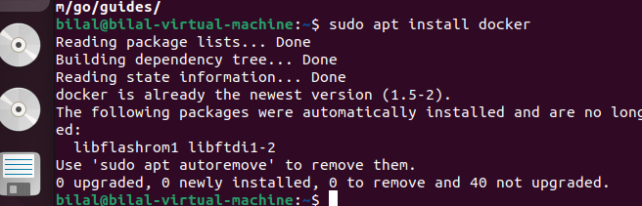

**Step 2**: Verify the installation

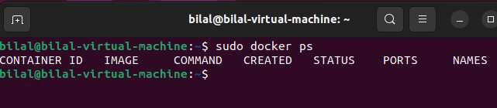

**Docker is now successfully installed!!!!!!!!!!!!**

1. **Kubernetes**

* Kubernetes is an open-source platform for automating the deployment, scaling, and management of containerized applications. It was originally developed by Google and is now maintained by the Cloud Native Computing Foundation (CNCF).
* Kubernetes allows developers to deploy applications in containers and manage them at scale. It provides features such as automatic bin packing, self-healing, and horizontal scaling, which make it easier to run and manage applications in a distributed environment.
* Kubernetes is designed to be flexible and extensible, and it has a large and active community of users and developers. It is used by a wide range of organizations, including small startups and large enterprises, to deploy and manage applications at scale.

**We will use Microk8s**

* Microk8s is a lightweight, fast, and secure version of Kubernetes that is designed to be easy to install and use. It is developed by Canonical, the company behind the Ubuntu operating system, and is designed to be a simple and reliable way to get started with Kubernetes.
* Microk8s includes all of the core features of Kubernetes, such as automatic binpacking, self-healing, and horizontal scaling, but it is optimized for simplicity and ease of use. It can be installed on a wide range of platforms, including Linux, Windows, and Mac, and it can be run on a single node or on a cluster of nodes.
* Microk8s is a popular choice for developers who want to get started with Kubernetes quickly and easily, and it is also used by organizations that want a simple and reliable way to deploy and manage applications at scale.

### Step 1: Install MicroK8s on Linux

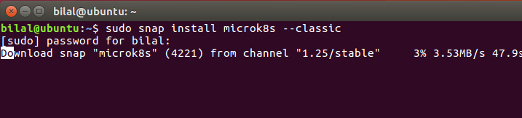

### Step 2: Install MicroK8s on Linux

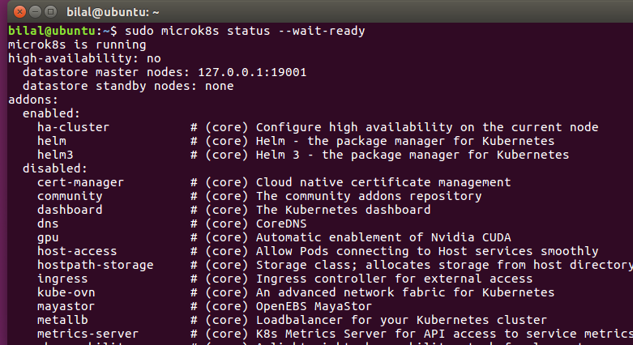

### Step 3: Enable the Services

### Step 4: Start and get namespaces using below commands

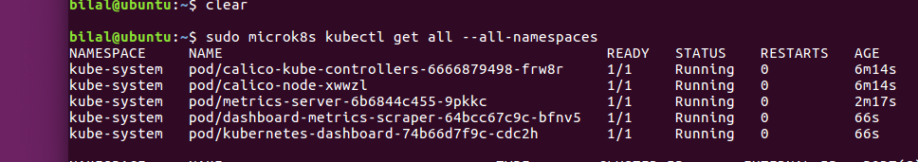

Step 5: **Access the dashboard**

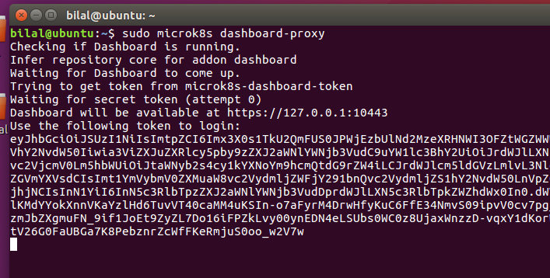

### Step 5: Paste the token and login

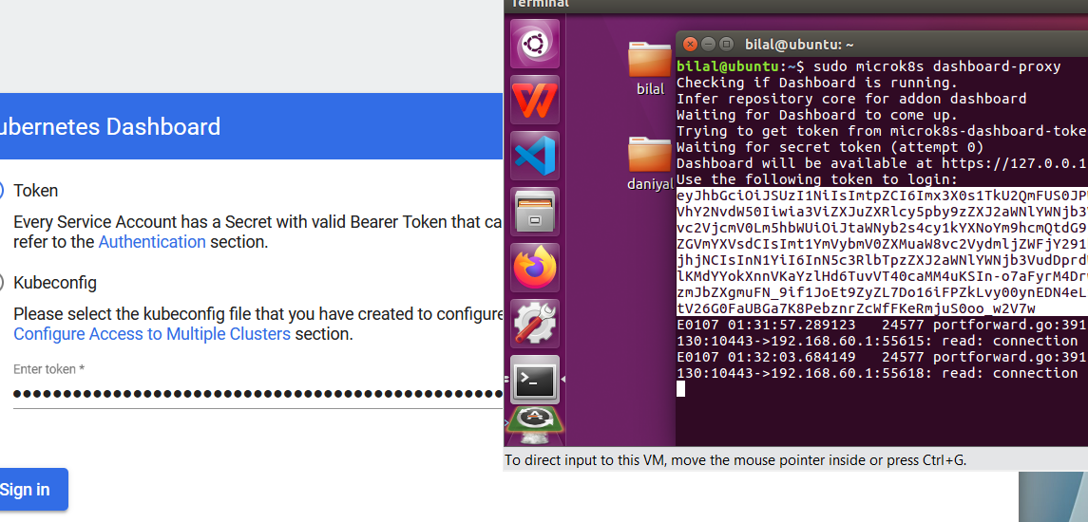

### Step 5: Login successfully

**Start or stop Kubernetes services** microk8s start and microk8s stop

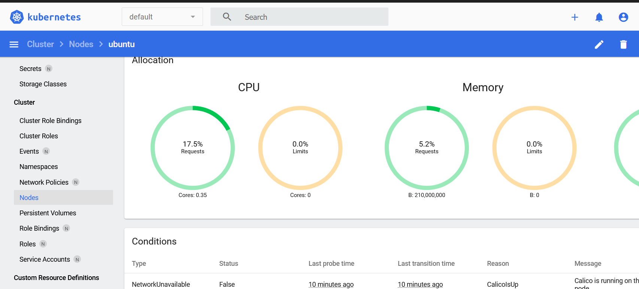

**Kubernetes is now successfully installed!!!!!!!!!!!!**

1. **Splunk**

* Splunk is a software platform that is used for analyzing, monitoring, and visualizing machine-generated data. It is commonly used for tasks such as log analysis, security analysis, and performance monitoring.
* Splunk allows users to search, analyze, and visualize data from a wide range of sources, including log files, application data, and machine data. It provides a range of tools and features for tasks such as data indexing, searching, and visualization, and it has a large and active community of users and developers.
* Splunk is used by a wide range of organizations, including small startups and large enterprises. It is a popular choice for data analysis and visualization because it is highly flexible, scalable, and powerful, and it has a wide range of integrations with other tools and systems.

### Step 1: Download Splunk Tar file and install

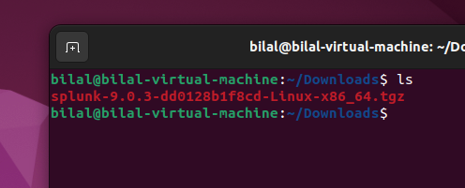

### Step 2: de – archive the tar files in /opt folder

**Command:** **Sudo tar xvzf “ splank_File “ -C /opt**

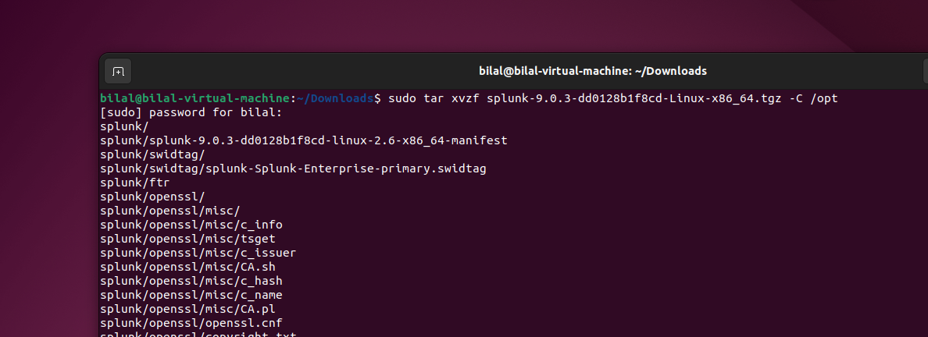

### Step 3: Start Splunk Services by navigating to cd /opt/Splunk/bin/

### Command: sudo. /Splunk start, sudo. /Splunk stop, sudo. /Splunk restart, sudo ./Splunk help

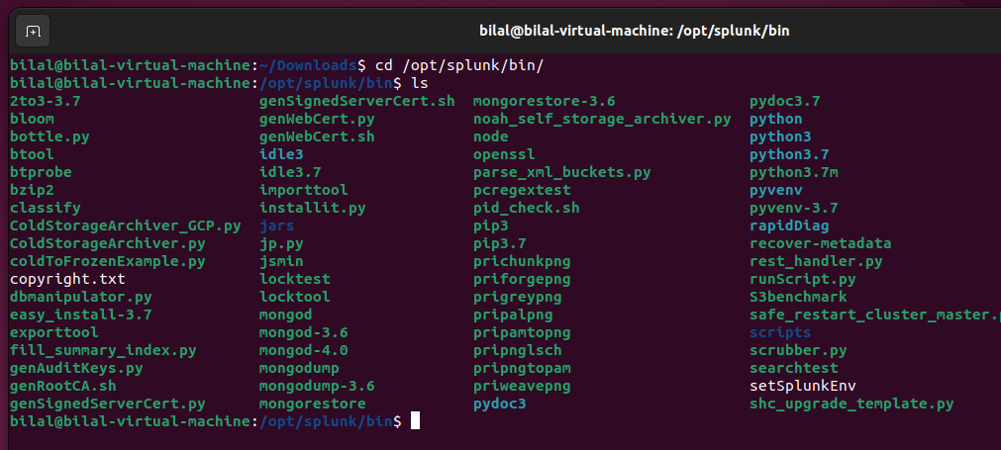

**Step 3**: start service usingsudo. /Splunk start

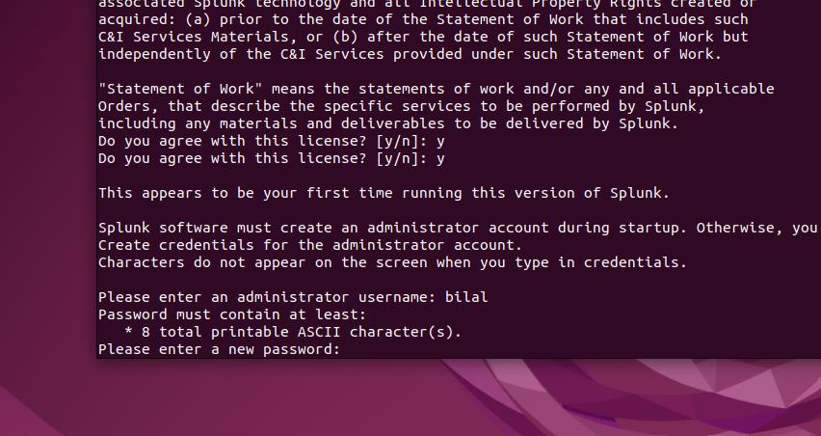

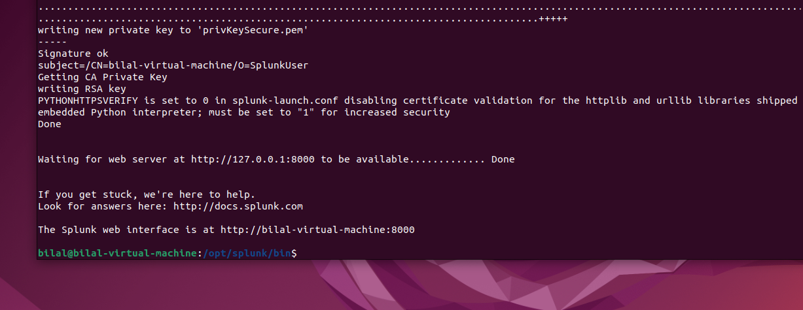

**Step 4**: Navigate to IP:8000 login with given credentials

**Splunk is now successfully installed!!!!!!!!!!!!**

**7. Ansible**

Ansible is an open-source IT engine that automates application deployment, cloud provisioning, intra service orchestration, and other IT tools.

Ansible is easy to deploy because it does not use any **agents** or **custom security** infrastructure on the client-side, and by pushing modules to the clients. These modules are executed locally on the client-side, and the output is pushed back to the Ansible server.

## **Step 1:** Install Ansible on RedHat/Cento’s systems

* + Install the EPEL repo
  + yum install epel-release

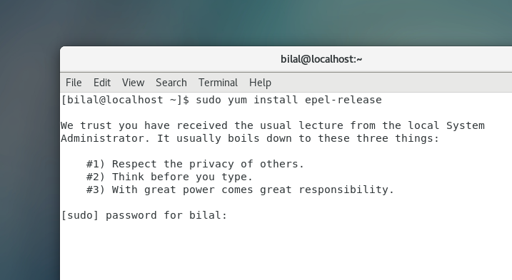

**Step 2**: Install the Ansible package.

* + sudo yum install -y ansible

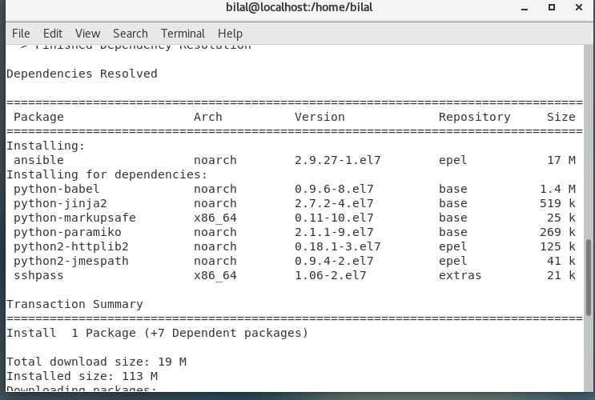

* + Update Package: sudo apt update / yum update

**Step 3**: Install the software properties common package.

* + install the software properties common package.

### Step 5: Setting up Ansible bash completion support

### sudo yum install python3-argcomplete

### sudo activate-global-python-argcomplete3

**Step 4:** Check install ansible version

**Ansible is now successfully installed!!!!!!!!!!!!**